Steps to deploy Tableau Server on Azure

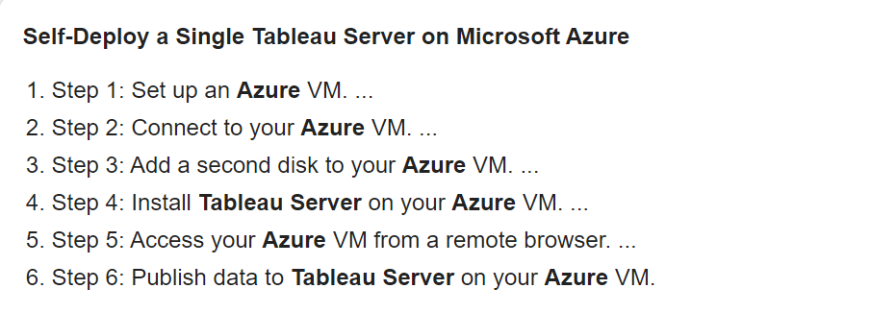

Tableau Server cost

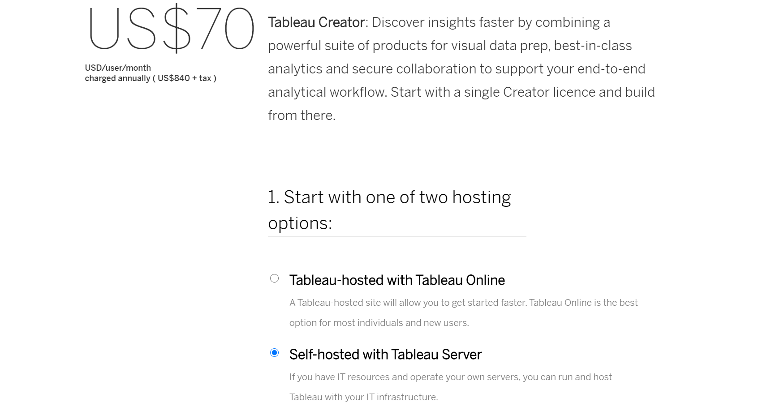

Cost of Azure VM

 An estimate of 60 euros per month for the Azure VM